## Team Members: Kendra Herrmann, Perry Donahue, Preeti Timalsina, A.J. Guevara, Nick Oelschlaeger

These are the terms of group collaboration and conduct that we agree on as a team.*

## Team Roles and the RACI Matrix

It’s pretty easy for the right hand to be in the dark about what the left hand is doing when you work in a team. One well-known method involves the use of something called a RACI chart. The acronym RACI stands for **responsible, accountable, consulted, and informed**. This is how each of the 4 components is defined:

**Responsible**: a team member who is directly responsible for successfully completing a project task.

**Accountable**: the person with final authority over the successful completion of the specific task or deliverable.

**Consulted**: someone with unique insights the team can consult.

**Informed**: anyone who isn’t directly involved, but you should keep up to speed.

Your task is to:

* Review the coming assignments, various tasks, and deliverables.
* Then, assign responsibility for them.* Two common approaches to plan are assigning roles that will stay the same throughout the semester, and rotating roles per assignment across the semester. These two approaches are not absolute, and are flexible to your individual team. Like this, each team’s RACI matrix will be unique.
* Finally, build a RACI matrix for your team using this table as a prompt.

|  |  |  |  |  |  |
| --- | --- | --- | --- | --- | --- |
|  | Kendra - SM | Perry - Dev | Nick - Dev | Preeti - Tester | A.J. – UI/UX |
| Context-Free Interview Guide | Responsible | Responsible | Responsible | Responsible | Responsible |
| User Stories | Responsible | Responsible | Responsible | Responsible | Responsible |
| Use Cases | Accountable | Consulted | Consulted | Responsible | Consulted |
| User Interface Wireframe | Accountable | Consulted | Consulted | Consulted | Responsible |
| DFD and Pseudocode | Accountable | Responsible | Responsible | Consulted | Informed |
| Overall Sprint Plan (Product Backlog) | Responsible | Informed | Informed | Informed | Informed |
| Prioritize and Group User Stories Sprint 1 | Responsible | Consulted | Consulted | Consulted | Responsible |
| Test Plans – Sprint 1 | Accountable | Consulted | Consulted | Responsible | Consulted |
| Prioritize and Group User Stories Sprint 2 | Responsible | Consulted | Consulted | Consulted | Responsible |
| Product Backlog – Sprint 2 | Responsible | Informed | Informed | Informed | Informed |
| Test Plans – Sprint 2 | Accountable | Consulted | Consulted | Responsible | Consulted |
| Test Results – Sprint 1 | Accountable | Consulted | Consulted | Responsible | Consulted |
| Review and Retrospective | Responsible | Responsible | Responsible | Responsible | Responsible |
| Product Backlog – Sprint 3 | Responsible | Informed | Informed | Informed | Informed |
| Prioritize and Group User Stories – Sprint 3 | Responsible | Consulted | Consulted | Consulted | Responsible |
| Test Plans – Sprint 3 | Accountable | Consulted | Consulted | Responsible | Consulted |
| Review and Retrospective – Sprint 2 | Responsible | Responsible | Responsible | Responsible | Responsible |
| Test Results – Sprint 2 | Accountable | Consulted | Consulted | Responsible | Consulted |
| Review and Retrospective – Sprint 3 | Responsible | Responsible | Responsible | Responsible | Responsible |
| Test Results – Sprint 3 | Accountable | Consulted | Consulted | Responsible | Consulted |
| User Acceptance Testing | Accountable | Consulted | Consulted | Responsible | Responsible |
| Final Documentation and Handover | Responsible | Consulted | Consulted | Consulted | Consulted |
| Presentation of Prototype | Responsible | Responsible | Responsible | Responsible | Responsible |
|  |  |  |  |  |  |

## Communication and Participation

We agree to communicate with each other via Teams/email/text regarding absences and team meetings.

We agree to participate in the group on a regular basis, meaning we will check in on Teams/email/text throughout the day.

Scheduling-wise, we understand Thursday and Friday evenings, as well as Saturdays and Sundays during the day, are our best times to plan a meeting. If you are going to miss a meeting, update the group on your progress.

On assignments where multiple people are “Responsible”, a lack of communication from one or more parties is considered non-participation and will be subject to consequences listed below.

## Work Product and Quality

Our definition of a high-quality work is:

A well-designed, validated, and verified interface that meets customer standards and expectations.

As a group, we are ok with planning submissions 13-24 hours in advance and we will plan to have deliverables drafted out and submitted to the team for checking 48 hours in advance to achieve the quality of work we agreed to. Dr. Hall will be contacted no later than 36 hours prior to the cutoff time for submission of the assignment if a draft has not been provided.

We will use the following software for our project R, PowerBI, Microsoft Office Suite, Teams, etc. Everyone acknowledges that they have access to the agreed-upon software.

The work product is “Done” when it has been reviewed by those listed as “Consulted”, “Informed”, and “Accountable” in the RACI chart and has been cleared by these parties for submission. In order to fully meet the definition of “Done”, the work product must also fulfill the definition of “high quality work” laid out above. This includes satisfactory UI/UX testing (e.g. Execution, Visual Consistency, Usability, etc.), to include real user testing and approval, when applicable.

## Policies and Procedures

What guidelines can we agree on to help us meet our goals and expectations?

Communicate if meetings will not be made, in the event a meeting has to be missed, send a progress report.

What is our method of conflict resolution?

Conversations with those directly involved in the conflict/task/issue. Including efforts to de-escalate and understand how to agree/resolution of the misunderstanding.

What is our minimally acceptable standard of intra-team professional conduct?

Communicate and submit drafts on time (48-hour rule for responsible parties).

When is it time to involve Dr. Hall for help if someone isn’t following our contract? What kind of things warrant her intervening?

If someone is not communicating at all or not sending updates for their projects, Dr. Hall will be involved.

If someone does not submit something they are responsible for and fails to communicate regarding the lack of submission.

## Consequences

How will we address non-performance?

Kendra will contact the person who failed to submit drafts within 24 hours of the agreed-upon time for draft submission. If a submission is not given to the team, Dr. Hall will be contacted.

What is our penalty structure will we use if someone isn’t following our contract? Are there differences for minor and major problems?

Minor – draft is a couple of hours late, communication issues (lack of), etc.

Major – not turning in a draft, not communicating about missing a draft submission, etc.

Minor penalty – talk to Kendra so she can contact the person

Major penalty – mention the person failing to perform in the upcoming sprint review.

What will we recommend to Dr. Hall if we need to involve her?

Point deductions for the individual, habitual lack of performance – removal from the group.

## Celebrating

What happens if something goes really well?

We will discuss as a team and do something to celebrate.

For individual tasks – we will recognize the person personally in Teams/text.

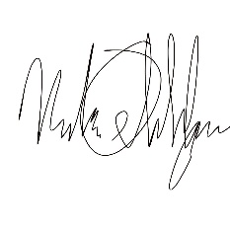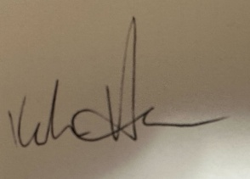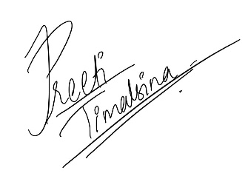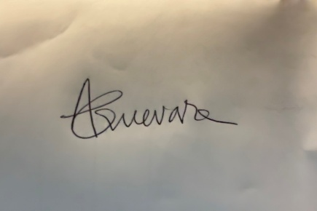  
Nick Oelschlaeger, Perry Donahue, Kendra Herrmann, Preeti Timalsina, A.J. Guevara